Alert Watch and Response Engine (AWARE)

Knowledge Base (KB) Editor

User Guide



July 2015

Prepared by Harris Corporation

CLIN 0007AC

Revision History

| Creation Date | Version No. | Description/Comments | Author(s) | Reviewer(s) | Review Type | Issue Date |
| --- | --- | --- | --- | --- | --- | --- |
| 02/14/2014 | 0.01 | Initial | B. Tjahjo | G. Welch S. Wang S. Greenacre M. Becker | Peer | 06/03/2014 |
| 08/27/2014 | 0.02 | Updated all screen shots; Added Generic Name in Table 2; Added Section 3.2.4 Copy Alert Type; Moved Delete Alert Type to Section 3.2.5; Moved Edit Alert Type to Section 3.2.6.  CLIN 0007AC added to cover sheet indicating, per VA PMO concurrence, that deliverable satisfies contractual requirement for System Administration Manual. | B. Tjahjo |  |  | 09/04/2014 |
| 02/23/2015 | 0.03 | Updated Figures 15, 16, 20, 21, 22, and 23.  Updated Table 3. | S. Greenacre |  |  |  |
| 07/28/2015 | 0.04 | Updated section 2 with the correct security key name.  Removed Programmer Key requirement from section 3.2.2 and added Alert Category Functionality. | S. Greenacre |  |  |  |
|  |  |  |  |  |  |  |
|  |  |  |  |  |  |  |
|  |  |  |  |  |  |  |
|  |  |  |  |  |  |  |
|  |  |  |  |  |  |  |
|  |  |  |  |  |  |  |
|  |  |  |  |  |  |  |
|  |  |  |  |  |  |  |
|  |  |  |  |  |  |  |

Table of Contents

1 Introduction 1

2 VistA Security Key 1

3 User Instructions 1

3.1 Logging In and Starting KB Editor 1

3.2 KB Editor Main Page 2

3.2.1 Alert Category 2

3.2.2 Add/Edit Alert Category 3

3.2.3 Alert Type 5

3.2.4 Copy Alert Type 6

3.2.5 Delete Alert Type 7

3.2.6 Edit Alert Type 8

3.2.7 Adding/Deleting Alert Types and Adding/Deleting Elements in Alert Type Groups 18

4 Appendix A - Order Dialog/Orderable Item Site Customization/Tailoring 21

5 Appendix B - Create a New Alert Type and Associated -Reminder Dialog 22

List of Tables

Table 1 - Alert Category Field Definition 5

Table 2 - Alert Type Reminder Dialog Field Definition 8

Table 3 - Alert Type OrderDialog Field Definition 12

List of Figures

Figure 1 - URL Field 1

Figure 2 - Authentication Page 2

Figure 3 - Alert Category 3

Figure 4 - Page Navigator 3

Figure 5 - Add/Edit Alert Category 4

Figure 6 - Delete Alert Selections 4

Figure 7 - Notification Alert Selections 5

Figure 8 - Alert Type 6

Figure 9 – Copy Alert Type Confirmation Dialog 7

Figure 10 – New Alert Type Created Message 7

Figure 11 - Delete Alert Type Confirmation Dialog 7

Figure 12 – Alert Type Deleted Message 8

Figure 13 - Alert Type Reminder Dialog Page 8

Figure 14 – Search 10

Figure 15 - Order Dialog Group Tab 11

Figure 16 - Edit an Order Dialog Element 12

Figure 17 - Sample Guidance Message 14

Figure 18 - Sample Guidance Message at Bottom of the Alert Type Page 14

Figure 19 - Successful Alert Type Update Message 14

Figure 20 - Follow-Up Dialog Group Tab 15

Figure 21 - Edit Follow-Up Dialog Element 16

Figure 22 - Comments Dialog Group Tab 17

Figure 23 - Edit Comments Dialog Element 17

Figure 24 - Add Alert Type 18

Figure 25 - Delete Confirmation 20

Figure 26 - Add a New Alert Type 23

Figure 27 - Add Newly-Created Reminder Dialog 28

Figure 28 - Add Alert Type Dialog Elements 30

Figure 29 - Search Alert Type 30

Figure 30 – Update Additional Finding and Progress Note 33

Figure 31- Activate the Alert Type 35

# Introduction

This document explains how to use the Knowledge Based (KB) Editor. The KB Editor is a web application designed to be used with Alert Watch and Response Engine (AWARE).

The KB Editor is essentially a web Interface to add or update records in the VistA’s VEFA CRITICAL ALERT CATEGORY and VEFA Tracked Critical Alert (ALERT TYPE) files. It also has the capability to validate Alert type against a corresponding VistA Reminder Dialog and underlying Order Dialogs for doing follow-up actions. It also represents a Knowledge Base design with directions for a site to customize its corresponding Reminder Dialog.

These Alert Categories and Alert Types are used by the CPRS (Computerized Patient Record System) with the AWARE extension to track critical alerts.

This document is intended for Clinical Application Coordinators (CACs), and knowledge of Reminder Dialog, Text Integration Utilities (TIU), and Health Factors design are essential in conjunction with using the Knowledge Based (KB) Editor.

# VistA Security Key

To be able to add or modify rule in the KB Editor, the user must own the following VistA security key:  
VEFA AWARE ADD/EDIT KB RULE.

Users holding this security key may add or edit KB rules (AWARE Alert Category and Alert Type).

# User Instructions

## Logging In and Starting KB Editor

The KB Editor can be accessed using the following URL:  
http://<HostServer>/csp/aware/kbeditor/kbeditor.csp

<HostServer> is the web server or IP address where the KB Editor is hosted.



Figure - URL Field

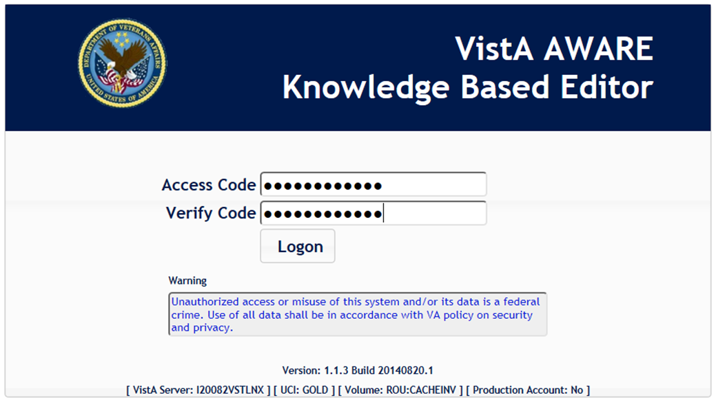

Figure - Authentication Page

The first page of the KB Editor is a login page. User must provide his/her VistA user Access and Verify codes and click the Logon button to login into KB Editor.

## KB Editor Main Page

After a successful login, the user will be directed to the KB Main page that shows a list of Alert Category and Alert Type records.

### Alert Category

Alert Category records are stored in file #19008 (VEFA CRITICAL ALERT CATEGORY). For an alert to be considered an AWARE (critical) alert, its’ category must be in this file.

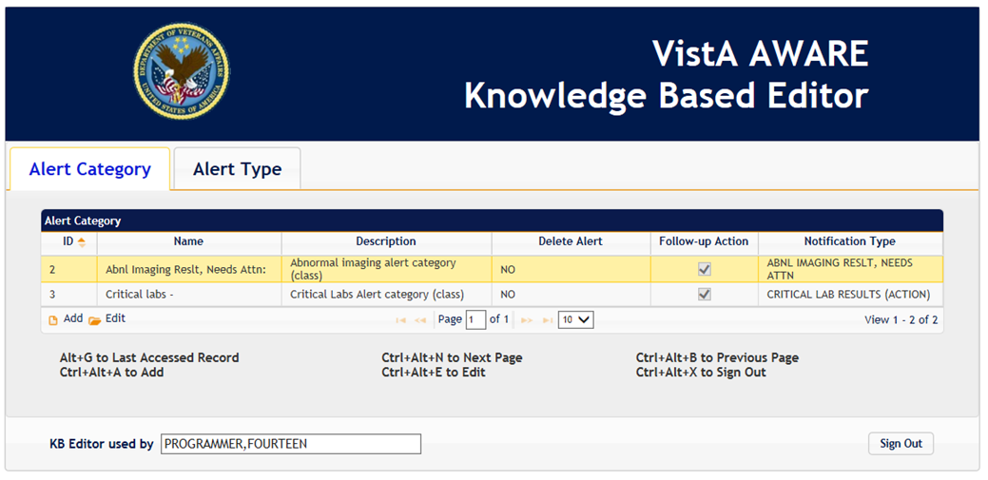

Figure - Alert Category

Only users with VEFA AWARE ADD/EDIT KB Rule security key can edit the description field. Section 3.2.2, Add/Edit Alert Category, explains each field in detail.

**Page Navigator**  
On the bottom of the grid is a page navigator to navigate records.

By default, ten records per page will be populated in the table. Users may change the amount of records displayed in the table by selecting a number from the drop down list.

Users may also navigate to different pages by entering page number or by using the Next, Previous, First and Last buttons.

Page Navigator

Figure - Page Navigator

**Keyboard Page Navigation**Shortcut keys are also provided to navigate between pages. Use Ctrl+Alt+N to go to the next page and Ctrl+Alt+B to go back to previous page. To return to the last record selected for that tab, use Alt+G while the focus is on the tab.

**Sign Out**User may log off from the KB Editor by clicking the Sign Out button (at the bottom right corner of the page) or by using a keyboard shortcut Ctrl+Alt+X key. This will clear the session and cookies associated with the KB Editor,

### Add/Edit Alert Category

**Alert Category Functionality**

* Users only need VEFA AWARE ADD/EDIT KB RULE key (no need programmer key) to do add/edit/delete. Programmer key can still do all those three operations.
* User can only add new Alert Category. It must be unique .
* User can freely edit Alert Category fields except name.
* User can edit Alert Category name if
  + The original name doesn’t exist in Alert View and
  + The original name is not active in Alert Type and
  + The new name doesn’t exist in Alert Category
* User can delete Alert Category if
  + It’s not being used in Alert Viewer and
  + It’s not being used in Alert Type

While on the Alert Category tab, users can add an Alert Category record by using the keyboard shortcut Ctrl+Alt+A key or by clicking the Add button on the bottom panel of the Alert Category page. To edit a record, select the record and then use Ctrl+Alt+E shortcut, double left click, or click on the Edit button.

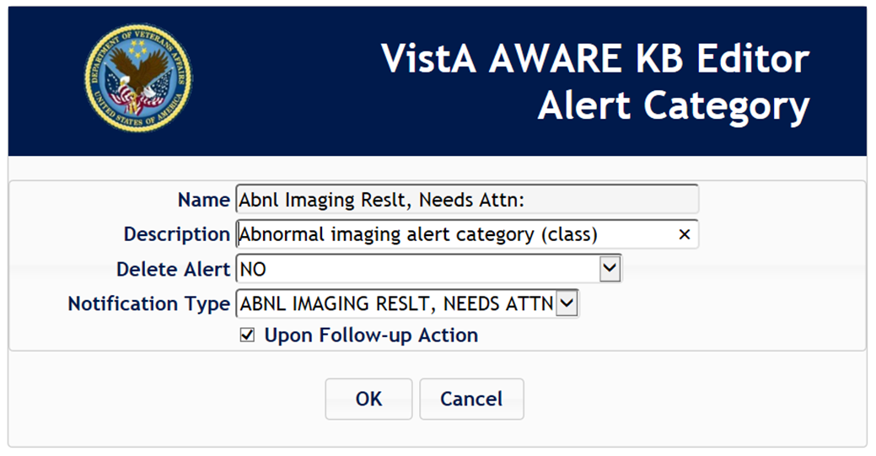

Figure - Add/Edit Alert Category

**Delete Alert Selections**“No” is the default value to not allow deletion or acknowledgment of alert unless follow-up actions are made.

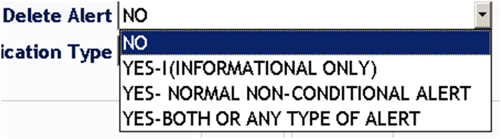

Figure - Delete Alert Selections

**Notification Alert Selections**

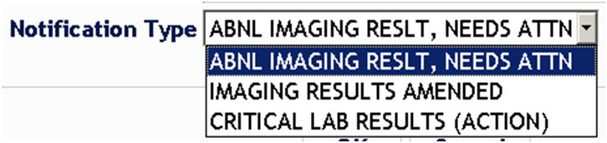  
Figure 7 - Notification Alert Selections

The following Table 1 describes each field shown in Figure 5 - Add/Edit Alert Category.

Table 1 - Alert Category Field Definition

| **Field** | **Description** |
| --- | --- |
| Name | This name field is one of few fields used to identify that an alert is tracked as an AWARE alerts (critical alerts). |
| Description (I) | Free text field. |
| Delete Alert | This field Indicates alert may or may not be deleted. “No” is default value to not allow deletion or acknowledgment of alert unless follow-up actions are made |
| Notification Type | This field is used to identify that an alert with this notification type will be tracked by AWARE. |
| Upon Follow-up Action | This field indicates the alert may or may not be processed upon follow-up action. The default value is “checked”. Currently this field is used for information only, for the programmer’s benefit. |

(I) = Input

**Keyboard Navigation on Select Box**While on the select box, use the Alt+Down Arrow key combination to list all available items in the select box, and then use Down/Up arrow keys to navigate through the list. Press Enter to select the item.

**Saving Record**Click on the OK button to save the Alert Category or the Cancel button to abandon the changes.

### Alert Type

Alert Type records are stored in file #19007 (VEFA Tracked Critical Alert).

The uniqueness of Alert Type record is based on the Alert Type name and Alert Category.

Alert Type records have a dual purpose, one is to identify an AWARE (critical) alert, and the other is to direct CAC for site-specific use from the top level Reminder Dialog, the Dialog Groups and their Dialog elements in Reminder Dialog file.

Some of the information defined in this file provides directions for site customization upon delivery for a site to tailor an associated Reminder Dialog for this alert type. The associated Reminder Dialog will contain the actual Alert type follow-up actions available for a provider to address an alert with this Alert type. Also, the Reminder Dialog elements in the designed Reminder Dialog will be validated, reaffirmed, and reflected in certain fields of the Alert type. The fields in the Alert type will not determine, but will only provide directions for making an intended associated Reminder Dialog that will be shown to the user in CPRS via subsequent CPRS/AWARE logic. It also provides viewable documentation of the detail information of actual Reminder Dialog elements in a Web GUI display to make it easier to see the functionality included for desired follow-up actions. CPRS will read the actual Reminder Dialog during TIU Note generation with CPRS/AWARE processing.

Only a CAC should create and maintain Alert Type records. Understanding the alert types associated with VistA Reminder Dialog along with its site specific is critical to having a meaningful and well-defined alert type.

This document will first define each field and explain how the fields are related to an associated VistA Reminder Dialog. Four Alert types are provided with the AWARE installation for providing directions for any additional site-specific customization. These are Prostate Specific Antigen, Fecal Occult Blood, Abnormal X-Ray, and Mammogram Alert types. Associated template Reminder Dialogs with these four Alert types are also provided with the installation. With these Alert types, only Reminder Dialog Order Dialog/Orderable Items need to be edited for customization/ tailoring specific to a site. This is specified in the Order Dialog tab elements of the each Alert type. This is the only editing required of these existing four Alert types. The outline of this work for this customization/site tailoring is shown in Appendix A - Order Dialog/Orderable Items and other Site Customization/Tailoring. These outline steps are not described in detail as this work corresponds to normal Quick Order (Order Dialog) design with any associated Orderable item work performed by Clinical Application Coordinators(CACs). This in general refers to any lab, medication, consult, imaging or procedure quick orders with reference to site-specific lab test names, medications, consult and associated consult services, imaging, or procedure values. It is beyond the design of this manual for specifying the exact steps for this work as these details are part of standard CAC procedures for doing such work.

Upon delivery, “VEFA” named placeholder fields are provided in the Alert type elements under the Orders tab for Orderable items and Order Dialog whose values need to be replaced with actual site-specific ones in the associated Reminder Dialog. Also, this site customization/ tailoring of the four delivered Alert types should be made first for initially using AWARE before considering any additional customization or creating/designing any new Alert type.

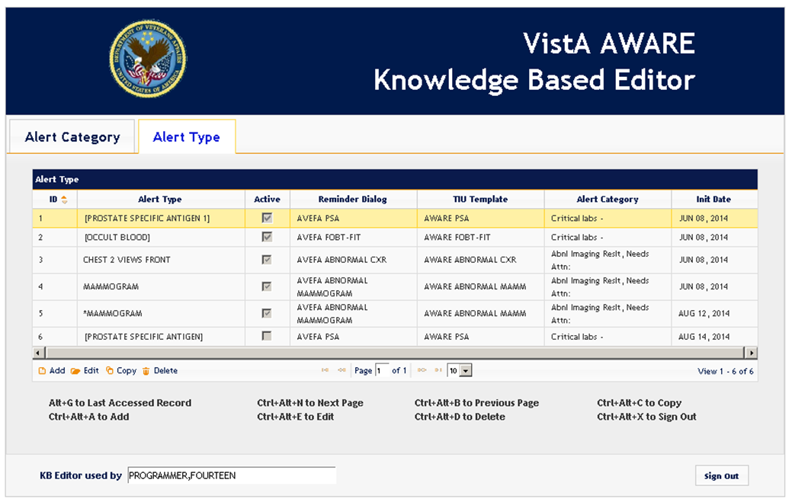

Figure - Alert Type

The Alert Type tab has similar page navigator functions as Alert Category.

### Copy Alert Type

To copy Alert Type, click Copy or press Ctrl+Alt+C from the Alert Type Page. The confirmation is required before user can copy an Alert Type.

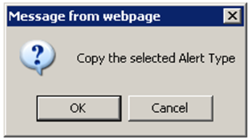

Figure – Copy Alert Type Confirmation Dialog

Upon successful copy, a new Alert Type with the same name as the source prefixed by “*” is created and a success notification will be shown to the user.

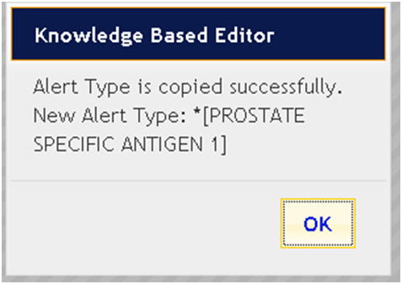

Figure – New Alert Type Created Message

### Delete Alert Type

To delete Alert Type, click Delete or press Ctrl+Alt+D from the Alert Type Page. The confirmation is required before user can delete an Alert Type.

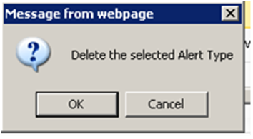

Figure - Delete Alert Type Confirmation Dialog

Upon successful deletion, a success deletion notification will be shown to the user.

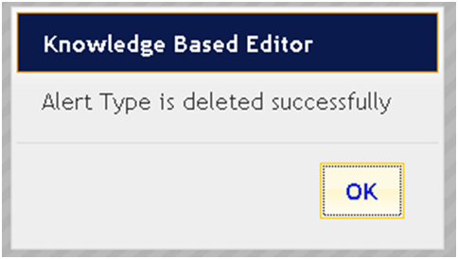

Figure – Alert Type Deleted Message

### Edit Alert Type

To edit a highlighted Alert Type, click the Edit button or press Ctrl+Alt+E from the Alert Type Page.

The Alert Type page also uses similar shortcut keys and page navigator as the Alert Category.

#### Alert Type Reminder Dialog Page

An Alert Type Reminder dialog page (shown below) points to the associated Reminder Dialog with its three groups as represented via corresponding tabs.

**All fields should already be filled for the four Site delivered Alert Types except for the Text Integration Utility (TIU) Template field, and the Active and Initiation fields.

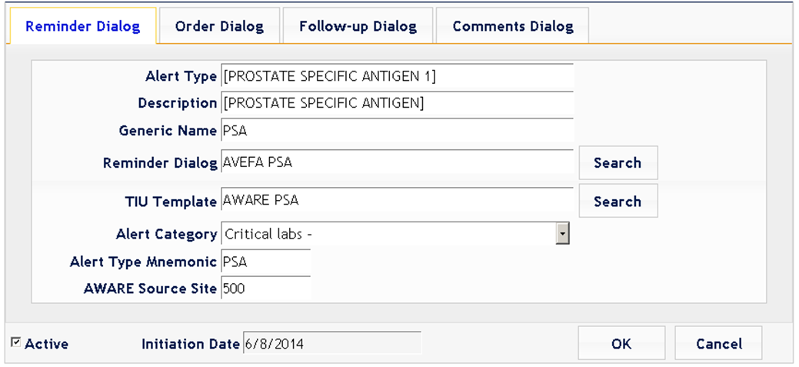

Figure - Alert Type Reminder Dialog Page

The following Table 2 describes each field shown in Figure 13 - Alert Type Reminder Dialog Page.

Table 2 - Alert Type Reminder Dialog Field Definition

| **Field** | **Description** |
| --- | --- |
| Alert Type (I) | This field represents type of alert to be tracked by AWARE. ** |
| Description (I) | Free text to describe the Alert Type |
| Generic Name (I) | This field represents a generic name of similar alert type with some variation. Example: PSA is generic name for [PROSTATE SPECIFIC ANTIGEN] |
| Reminder Dialog (I) | This is a pointer into Reminder Dialog file (#801.41) for an associated Reminder Dialog of type “R” (Reminder). For An alert type to be tracked, it must have a Reminder Dialog value defined here. The user may use the Search button to select a Reminder Dialog associated with this Alert Type. |
| TIU Template (I) | This is pointer to a TIU template in the TIU template file (#8972) connected to the aforementioned Reminder Dialog. For an alert type to be tracked and followed-up in CPRS, it must have this TIU template. This template will be used by CPRS to generate follow-ups note. Users may use the Search button to select a TIU template to associate with this Alert Type. The TIU template chosen needs to be linked with the associated Reminder Dialog through parameterization via the PARAMETER DEFINITION NAME: TIU TEMPLATE REMINDER DIALOGS (See AWARE_Install_Setup_Validation_Testing_Steps_1_0.doc) |
| Alert Category (I) | This is an item of Alert Category file (19008). For an alert type to be tracked, it must have a corresponding Alert Category. |
| Alert Type Mnemonic (I) | Mnemonic is a short representation of the Alert Type (typically an initial of the Alert Type name). The mnemonic is used to easily identify Reminder/Order dialogs and tie them to the Alert Type. This is a required field and its’ usage is enforced in other Alert Type elements. |
| AWARE Source Site (I) | This is the site number where the Alert Type was first created. This should be modified only if a user defines a new Alert type and the user’s own site station number should be entered. It should NOT be modified for the 4 delivered Alert types provided in an AWARE installation as these were designed with a station value (500) from another originating site. This is a required field and its’ usage is enforced in certain Alert type elements. |
| Active (I) | This flag indicates that this Alert Type is ready to be used. Users may freely activate or deactivate this flag, but the user should not make this value “ACTIVE” until the Reminder Dialog has been completely designed and customized for a specific site including the defining and specification of any Order Dialog/Orderable items into the associated Reminder Dialog with the Alert type. Also, the Alert Type Validator may deactivate this flag when an error is found. The Validator will be invoked when the Alert type elements are saved. |
| Initiation Date (O) | The Initiation date is initially set to the current date/time for the commencement of AWARE tracking for this Alert type. The Alert Type Validator checks the associated Reminder/Order dialogs as well as the Active flag. Once the Active flag is set, the initiation date is set and remains the same. ** |

(I) = Input, (O) = Output

**Search**  
The Search button should be utilized if there is potentially large amount of selection options for a particular field. The Search function will pop up a list of records with name that start with the word entered in the associated edit box. The screen below shows the search popup for the Reminder Dialog filed for all Reminder Dialog “R” type names starting with the word “AVEFA”. The four delivered Reminder Dialogs start with the word “AVEFA”.

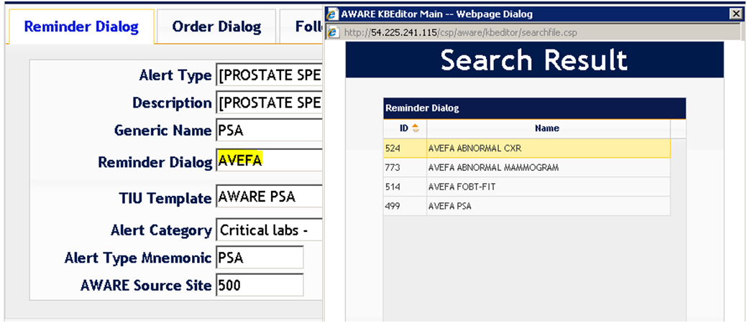

Figure – Search

To select a reminder dialog, find the name in the list, select the row and double-click or press the Enter key. The reminder dialog edit box will be populated with the selected name. To exit without selecting, close the page or press Ctrl+Alt+X key.

**Saving Alert Types and the Validator**Click the OK button to save the Alert Type or the Cancel button to abandon changes.

When saving the Alert Type, the program will invoke the Validator to validate Alert Type elements with Reminder and Order Dialogs information against an existing Reminder Dialog. Another purpose of the Validator is to guide CAC to customize or design a working Reminder Dialog. The four delivered Alert types with the AWARE installation provide directions for subsequent elements and site tailoring of associated template Reminder Dialogs that are also delivered with the installation.

In addition to the steps described in this main document, an outline of additional steps for specific customization/tailoring for Order Dialogs/Orderable Items is described in Appendix A - Order Dialog/Orderable Item Site Customization/Tailoring

Lastly, Appendix B - Create a New Alert Type and Associated -Reminder Dialog shows how a new Alert Type can be defined/constructed. (Note, this is not needed for the site customization/tailoring of the 4 delivered Alert types)

#### Alert Type Dialog Groups

The Reminder Dialog file (#801.41) has multiple dialog types. For the purpose of critical alert tracking, Alert Type uses three Reminder Dialog types – Reminder type “R”, Dialog Group type “G” and Dialog Element type “E”.

Hierarchically speaking, Alert Type has a parallel structure to a Reminder Dialog. First, a Reminder dialog with type “R” (Reminder) needs to be defined for the Alert type. The Alert type has three analogous sections (Order Dialog, Follow-up Dialog, and Comments Dialog) paralleling Group Dialogs needed in the associated Reminder Dialog.

Each section contains Alert type elements with directions for describing associated Reminder dialog elements.

While the Alert type Validator action does not validate against the groups, it is recommended Alert type and Reminder dialog files have similar group name structure based on functionality of the dialogs. A similar structure for the Reminder dialog elements in each Group (“G”) type Reminder Dialog should be followed as well as the same sequence in the order of Alert Type Group elements. The names for associated Reminder Dialog elements should follow the naming convention of “AW”+ (AWARE Source Site) (Alert Type Mnemonic) (Element Description), i.e. (AW500 PSA Order Repeat PSA). The delivered Reminder Dialogs to your site were derived from site”500”. This is the meaning for the AWARE Source Site. The AWARE Source Site to use is “500”. It is not the same as your own site number.

#### Order Dialog Group Tab

The image below shows all dialog elements deemed to be Order Dialogs in the Order Dialog Group.

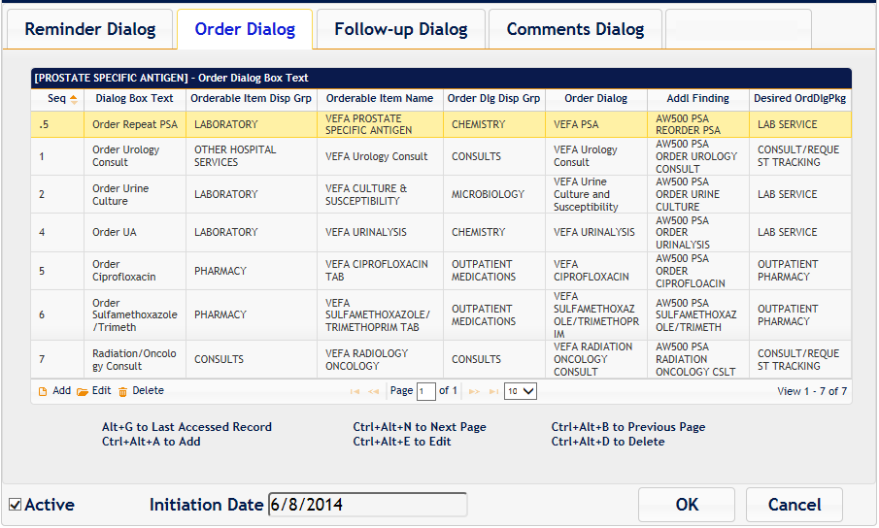

Figure - Order Dialog Group Tab

While moving from tab to tab, it is likely the previously selected row in the grid is no longer selected, Alt+G will take user to the last accessed row of the current tab.

If multiple pages exist for a group, the user can click the Next button or press Ctrl+Alt+N to move to the next page, or click Previous button or press Ctrl+Alt+B to move to the previous page.

#### Edit an Order Dialog Element

To edit a highlighted Order Dialog Element, click the Edit button or press Ctrl+Alt+E.

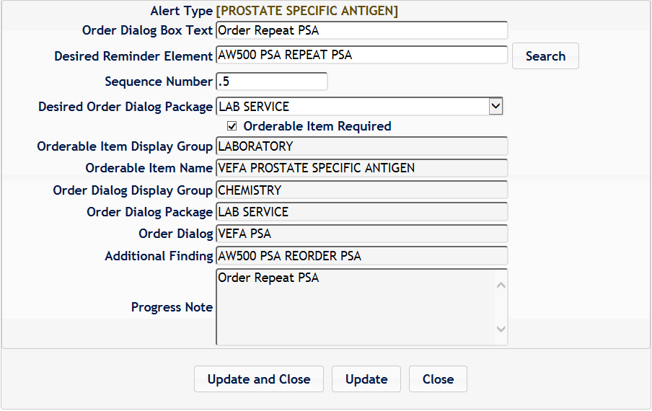

Figure - Edit an Order Dialog Element

The following Table 3 describes each field shown in Figure 16 - Edit an Order Dialog Element.

Table 3 - Alert Type OrderDialog Field Definition

| **Field** | **Description** |
| --- | --- |
| Alert Type (O) | This Read Only field is the same field as in the reminder dialog page. It is repeated here for informational only. ** |
| Order Dialog Box Text (I) | This Order Dialog text is to give guidance to CAC to update dialog element’s Dialog/Progress Note field with similar text. During TIU Note generation process, this text will be shown in reminder checklist. ** |
| Desired Reminder Element (I) | This is the dialog element for the Reminder. The main purpose of this element is to give guidance to CAC to create similar dialog element in the Reminder Dialog file. The “Pre-made” Alert Types and the corresponding Reminder Dialogs as template Reminder Dialogs associated with these Alert Types are delivered with the installation |
| Sequence Number (I/O) | The sequence number of the reminder element. |
| Desired Order Dialog Package (I) | This is the Order Dialog package associated with the dialog element. The main purpose of this field is to give CAC a guidance to use similar package during construction of dialog element in Reminder Dialog file. It is the responsibility of CAC to correctly attach this package to the dialog element. |
| Orderable Item Required (I) | This field indicates whether or not the Orderable Item is required for this dialog element. Orderable Item is part of dialog element definition. The field is a pointer to file Orderable Items (#10.43). |
| Orderable Item Display Group (O) | This is the Display Group that the orderable item is a member of. This field is filled during the Update process and provided to guide CAC to construct dialog element with the proper orderable Item Display group. |
| Orderable Item Name (O) | This is the Orderable item name for the dialog element. This field is filled during the Update process and provided to guide CAC to construct dialog element with the proper Orderable Item name. |
| Order Dialog Display Group (O) | This is the Display Group of dialog element’s Finding Item. This Finding Item is an item of Order Dialog file (#101.41). This field is filled during the Update process and provided to guide CAC to construct dialog element with the proper Finding Item. |
| Order Dialog Package (O) | This is the package of dialog element’s Finding item. This Finding Item is an item of Order Dialog file (#101.41). This field is filled during the Update process and provided to guide CAC to construct dialog element with the proper Finding Item. |
| Order Dialog (O) | This is the dialog element’s Finding Item field, which is an item of Order Dialog file (#101.41). This field is filled during the Update process and provided to guide CAC to construct dialog element with the proper Finding Item. |
| Additional Finding (O) | This is the additional finding that should be posted for this dialog element. This field is filled during the Update process and provided to guide CAC to construct dialog element with the proper additional finding. It is used for Alert follow-up tracking purposes. The additional Finding is an item of file Health Factors (#9999999.64). |
| Progress Note (O) | This is the progress note attached to the dialog element. This field is filled during the Update process. |

(I) = Input, (O) = Output

**Update**When AWARE is installed, 4 defined Alert Types are provided. These types will have associated template Reminder Dialog and Dialog Elements. The CAC is responsible for modifying these dialogs based on the Alert Types. The Update function is designed to guide the CAC to associate those reminder dialog elements to Alert Type elements via linkage, and then to provide direction to do specific customization/tailoring for replacing placeholder fields for any Order Dialogs/Orderable items with actual site specific Order Dialogs/Orderable Items. After this replacement is made via the Reminder Dialog builder, these changes can be reflected in the KB Editor via the use of the “Update” function (by clicking the Update button). A subsequent “Validation” message will provide any further directions for next needed customization/tailoring or will indicate an “OK” validation.

Essentially, the Update function saves the fields into Alert Type file (#19007) and invokes the Validator to validate and update Alert Type data.

The Validator returns not only the validation and updates the result back to the user but most importantly shows guidance messages to the users to help them determine what to do next. At the end of the process, the users will see “Alert Type is updated successfully” message. This indicates that all dialogs (reminder, dialog group, and dialog elements) have been created and linked to the Alert Type properly.

To perform the Update function, click on the Update button. User will see either a guidance message or successful message.

Sample Guidance Message

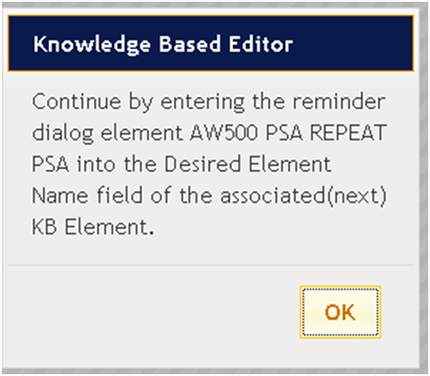

Figure - Sample Guidance Message

Upon closing the confirmation dialog, this guidance message will also appear at the bottom of the Alert Type page.

Sample Guidance Messager at Bottom of the Alert Type Page

Figure - Sample Guidance Message at Bottom of the Alert Type Page

**Successful Alert Type Update**

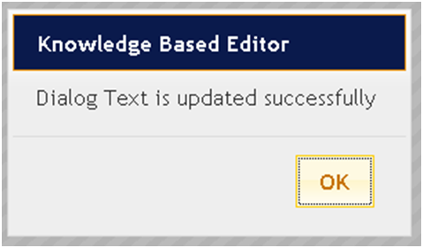

Figure - Successful Alert Type Update Message

**Update and Close**The “Update and Close” button performs update function and then closing the form. The Validation Result will still be displayed at the bottom of the next page.

**Close**The Close button will close the form without performing any updates. The Validation Result from the previous action will still be displayed at the bottom of the next page.

#### Follow-Up Dialog Group Tab

All dialog elements that are deemed to be follow-up should be added in this group. The structure and functionality of this group is similar to the Order Dialog Group. Please see section 3.2.7.2, Add an Order Dialog Element, for more information.

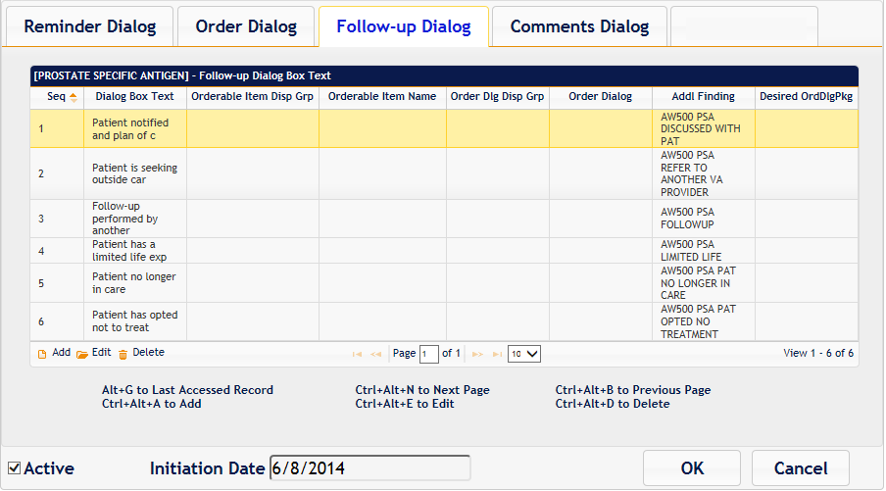

Figure - Follow-Up Dialog Group Tab

#### Edit Follow-Up Dialog Element

To edit a highlighted Follow-up Dialog Element, click the Edit button or press Ctrl+Alt+E.

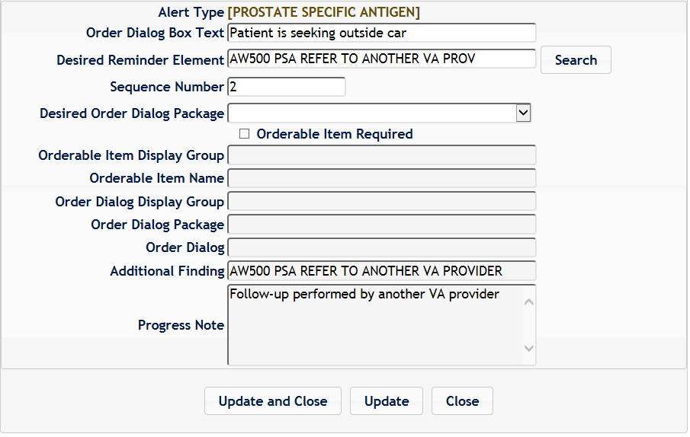

Figure - Edit Follow-Up Dialog Element

Refer to section 3.2.6.4, Edit an Order Dialog Element, for fields’ definition and explanation of Update, Update and Close and Close functions.

#### Comments Dialog Group Tab

All dialog elements that are deemed to be comments should be added in this group. The structure and functionality of this group is similar as Order Dialog Group. See section 3.2.6.3, Order Dialog Group Tab, for more information.

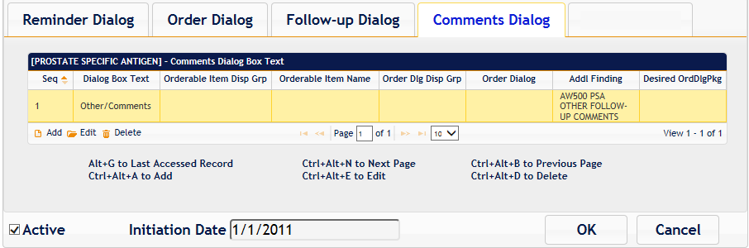

Figure - Comments Dialog Group Tab

#### Edit Comments Dialog Element

To edit a Comments Dialog Element, click the Edit button or press Ctrl+Alt+E.

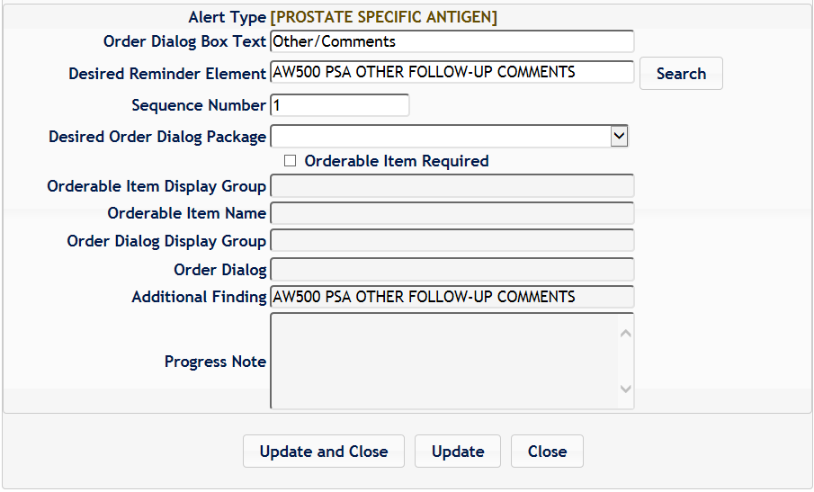

Figure - Edit Comments Dialog Element

Refer to section 3.2.6.4, Edit an Order Dialog Element, for fields’ definition and explanation of Update, Update and Close and Close functions.

### Adding/Deleting Alert Types and Adding/Deleting Elements in Alert Type Groups

This section contains generic instructions for adding/deleting elements, which could be followed for further customization of existing Alert types, or can be referenced in the making of complete new Alert types as explained in Appendix B - Create a New Alert Type and Associated -Reminder Dialog.

#### Add Alert Type

To add a new Order Alert Type, click Add or press CTRL+ALT+A from the Alert Type Page.

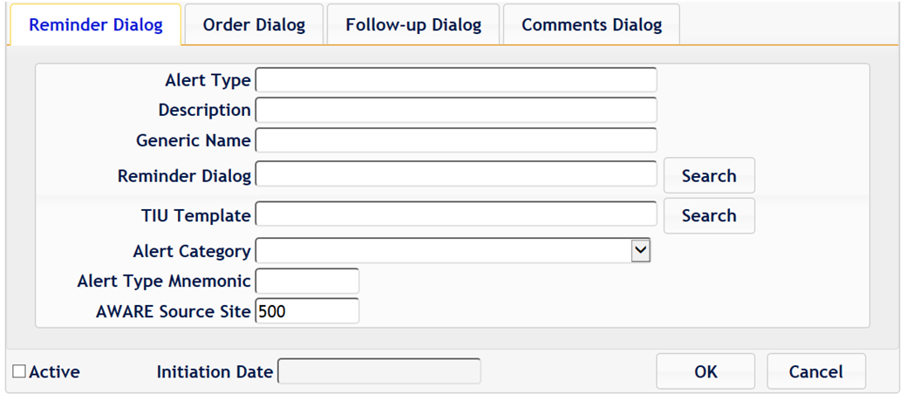

Figure 24 - Add Alert Type

All fields need to be filled. See section 3.2.6.1, Alert Type Reminder Dialog Page, for the description of these fields.

**NOTE**, a Critical lab Alert Type field has a lab test name bound with enclosing brackets [….], i.e. [PROSTATE SPECIFIC ANTIGEN] or [OCCULT BLOOD], etc. specified in the lab test name part of the DISPLAY TEXT field of an Alert Tracking VistA file record for this kind of alert (i.e., DISPLAY TEXT: NINETYTHR (N0893): Critical labs – [PROSTATE SPECIFIC ANTIGEN). See an example Alert tracking record with this DISPLAY TEXT below:

NAME: OR,100801,57;20364;3140220.210302

DATE CREATED: FEB 20, 2014@21:03:02 PKG ID: OR,57

PATIENT: NINETYTHREE,INPATIENT GENERATED BY: LABTECH,SEVENTEEN

GENERATED WHILE QUEUED: YES RETENTION DATE: MAR 22, 2014

**DISPLAY TEXT:** **NINETYTHR (N0893): Critical labs - [PROSTATE SPECIFIC ANTIGEN]**

ROUTINE TAG: RPTLAB ROUTINE FOR PROCESSING: ORB3FUP2

DATA FOR PROCESSING: 33717@OR|17618;3140220;2;CH;6859778.7899@LRCH

RECIPIENT: PROVIDER,OTHER

RECIPIENT TYPE: INITIAL RECIPIENT ALERT DATE/TIME: FEB 20, 2014@21:03:02

RECIPIENT: PROVIDER,SEVEN

ALERT FIRST DISPLAYED: FEB 20, 2014@21:03:39

FIRST SELECTED ALERT: FEB 20, 2014@21:03:39

RECIPIENT TYPE: INITIAL RECIPIENT ALERT DATE/TIME: FEB 20, 2014@21:03:02

RECIPIENT: PROVIDER,EIGHT

ALERT FIRST DISPLAYED: FEB 27, 2014@13:20:46

RECIPIENT TYPE: INITIAL RECIPIENT ALERT DATE/TIME: FEB 20, 2014@21:03:02

RECIPIENT: PROVIDER,NINE

**NOTE,** an “Abnl Imaging Reslt, Needs Attn:” Alert Type field has a imaging test name , i.e., CHEST 2V or MAMMOGRAM, etc. specified in the imaging test name part of the DISPLAY TEXT field of an Alert Tracking Vista file record for this kind of alert. See an example Alert tracking record with this DISPLAY TEXT below:

Select ALERT TRACKING NAME: OR,204,25;991;3140220.205336

ANOTHER ONE:

STANDARD CAPTIONED OUTPUT? Yes// (Yes)

Include COMPUTED fields: (N/Y/R/B): NO// - No record number (IEN), no Computed

Fields

NAME: OR,204,25;991;3140220.205336 DATE CREATED: FEB 20, 2014@20:53:36

PKG ID: OR,25 PATIENT: TWELVE,PATIENT

GENERATED BY: LABTECH,SEVENTEEN GENERATED WHILE QUEUED: YES

RETENTION DATE: MAR 06, 2014@20:53:36

**DISPLAY TEXT: TWELVE,PA (T0012): Abnl Imaging Reslt, Needs Attn: CHEST 2 V**

ROUTINE TAG: RPTRAD2 ROUTINE FOR PROCESSING: ORB3FUP2

DATA FOR PROCESSING: 6919591.9099~1

RECIPIENT: PROVIDER,EIGHT

ALERT FIRST DISPLAYED: FEB 20, 2014@20:57:55

FIRST SELECTED ALERT: FEB 20, 2014@20:57:55

RECIPIENT TYPE: INITIAL RECIPIENT ALERT DATE/TIME: FEB 20, 2014@20:53:36

#### Add an Order Dialog Element

To add a new Order Dialog element at the end of the existing elements, click the Add button or press Ctrl+Alt+A from the Order Dialog Group tab.

An equivalent Reminder Dialog element (“E” type) must also be created in same next sequential order in its Reminder group as shown in the Alert Type Order Dialog Group element listing. This is through the Reminder Dialog builder, DI Reminder Dialog Management

#### Add a Follow-Up Dialog Element

To add a new Follow-up Dialog element at the end of the existing elements, click the Add button or press Ctrl+Alt+A from the Follow-ups Dialog Group tab.

An equivalent Reminder Dialog element (“E” type) must also be created in same next sequential order in its Reminder group as shown in the Alert Type Follow-up Dialog Group element listing. This is through the Reminder Dialog builder, DI Reminder Dialog Management

#### Add a Comments Dialog Element

To add a new Comments Dialog element at the end of the existing elements, click the Add button or press Ctrl+Alt+A from the Comments Dialog Group tab.

An equivalent Reminder Dialog element (“E” type) must also be created in same next sequential order in its Reminder group as shown in the Alert Type Comments Dialog Group element listing. This is through the Reminder Dialog builder, DI Reminder Dialog Management

Also, there are specifics for a “PXRM Comments” type element described in Appendix B for a Comment Dialog element.

#### Delete an Alert Type’s Order/Follow-Up/Comments Dialog Element

To delete an Alert type’s Order/Follow-up/Comments Dialog Element, click the Delete button or press Ctrl+Alt+D from the appropriate Order Dialog, Follow-up Dialog, or Comments Dialogs Group tab. The confirmation is required before user can delete a dialog element.

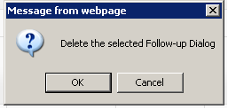

Figure - Delete Confirmation

The equivalent Reminder Dialog element as presented in the Desired Reminder Element field of the appropriate Order Dialog, Follow-ups Dialog or Comment Dialog Group tab should also be deleted via the Reminder Dialog builder option and DI Reminder Dialog Management.

# Appendix A - Order Dialog/Orderable Item Site Customization/Tailoring

For the following, refer to Step 2, refactoring the 4 delivered Template Reminder Dialogs of the companion guide, VistaInstallSetupValidation&InitialTesting.doc

1. For each Alert Type, make Quick orders with or w/o orderable items for medications, labs, consults, procedures, and imaging tests, etc. Use of consults also involves connecting to and/or setting up site-specific consult services.

First define and configure these quick orders (including defining any consults and their consult services, etc), for your site. Define with your own site equivalent lab test names, consult/consult services, medications and procedures.

1. Then edit the quick order name into each Reminder Dialog element’s “Finding Type” field, and if applicable, any associated orderable item name into the Reminder Dialog’s “Orderable Item” field. If no Orderable item applies, remove or enter no Orderable item in this field. . All this work involves replacing the leading “VEFA named placeholder Orderable Items and Order Dialogs delivered with the system with actual equivalent site defined values. Do this for all Reminder Dialog elements in the Orders Reminder Dialog Group.
2. Then click the “Update” function to perform Validation check for each of the corresponding KB Editor Order tab’s Order dialog element for these Reminder Dialog elements starting with the first element under the Order’s tab. This will then reflect the aforementioned updates in the Reminder Dialog Group’s Reminder Dialog elements into the corresponding Order tab’s Order dialog elements. These “updates” are shown for the “Output” (O) fields of the of the KB Editor’s Order tab's Order dialog elements.

The following fields should be updated upon a successful validation:

* Orderable Item Display Group
* Orderable Item Name
* Order Dialog Display Group
* Order Dialog Package
* Order Dialog

# Appendix B - Create a New Alert Type and Associated -Reminder Dialog

AWARE KIDS build comes with four pre-made Alert Types – Prostate Specific Antigen, Occult Blood, Chest X-RAY, and Mammogram.

The following instruction shows a user how to create/define a new Alert Type, let us call it “Gastrointestinal Carcinoma”. The instructions below are intended for an example of how to create this Alert Type.

1. First, do a design layout on paper for the basic description of the Alert Type for a lab or imaging type results, and the details for each of order dialog, follow-up dialog, and a Comments dialog group to properly address this type of alert.

Example:

**Tracked Alert**: Gastrointestinal Carcinoma

Alert Type: Associated Critical lab test or Abnormal Imaging test. AMYLASE as [AMYLASE] in serum as example lab test)

Alert Type Description: Gastrointestinal Carcinoma

Alert Category (Critical labs or Abnormal Imaging, in this case Critical labs)

Mnemonic (up to 4 letter short name representing this type of alert) “GAST” for example

Originating Station number at whose station this tracked alert is being defined (i.e. 580, etc)

**Order Dialog**

Bone CT Scan

Surgical Excision

Administer statin (like somatostatin)

**Follow-up action**

"Carcinoid syndrome" (flushing, and diarrhea)

Patient refer to another provider

Follow-up scheduled

**Comments**

General Comments

In KB Editor, add a new Alert Type using section 0, This section contains generic instructions for adding/deleting elements, which could be followed for further customization of existing Alert types, or can be referenced in the making of complete new Alert types as explained in Appendix B - Create a New Alert Type and Associated -Reminder Dialog.

1. Add Alert Type, and fill in the edit boxes in the Reminder Dialog tab with the information from the design layout in Appendix A - Order Dialog/Orderable Item Site Customization/Tailoring, for Alert type, Alert type description, alert category, mnemonic, and originating station. In the example data below, if this site’s station number was 580 as the originating site for this Alert type, enter this value in the AWARE Source site below. At this point, leave Reminder Dialog and TIU Template blank.

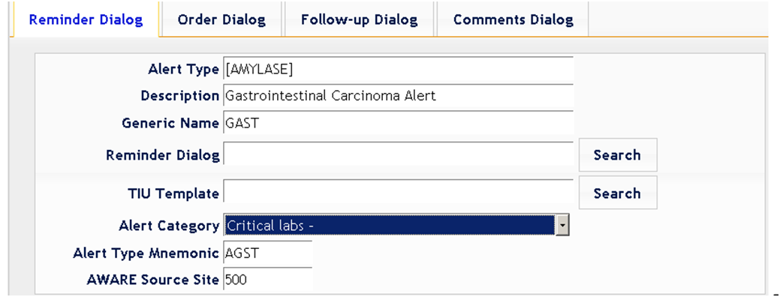

Figure - Add a New Alert Type

1. Create Reminder Dialog.

Open up VistA Reminder Dialog Builder. This is usually with Clinical Coordinator privileges starting with the Reminder Managers Menu such as below, and then the option DM Reminder Dialog management:

Select OPTION NAME: **REMINDER MANAGERS MENU** PXRM MANAGERS MENU Reminder Managers Menu

CF Reminder Computed Finding Management ...

RM Reminder Definition Management ...

SM Reminder Sponsor Management ...

TXM Reminder Taxonomy Management ...

TRM Reminder Term Management ...

LM Reminder Location List Management ...

RX Reminder Exchange

RT Reminder Test

OS Other Supporting Menus ...

INFO Reminder Information Only Menu ...

**DM Reminder Dialog Management ...**

CP CPRS Reminder Configuration ...

RP Reminder Reports ...

MST Reminders MST Synchronization Management ...

PL Reminder Patient List Menu ...

PAR Reminder Parameters ...

ROI Reminder Orderable Item Group Menu ...

XM Reminder Extract Menu ...

GEC GEC Referral Report

Select Reminder Managers Menu Option: **DM Reminder Dialog Management**

DP Dialog Parameters ...

**DI Reminder Dialogs**

DR Dialog Reports ...

IA Inactive Codes Mail Message

Select Reminder Dialog Management Option: **DI Reminder Dialogs**

**Dialog List** Mar 28, 2014@12:48:19 Page: 1 of 11

REMINDER VIEW (ALL REMINDERS BY NAME)

Item Reminder Name Linked Dialog Name & Dialog Status

1 ARD 00 ANTICOAGULATION AFIB

2 BL PCLC NEEDED

3 BL PHQ9 NEEDED UPDATE PHQ2 INFO TEXT Disabled

4 BL SUICIDE RISK NEEDED

5 CHF OUTPATIENT EDUCATION

6 CRD 00 ANTICOAG FOR AFIB

7 CRD ANTICOAG FOR AFIB

8 DIABETES - RETINAL EXAM PH DIABETIC RETINAL EXAM

9 DIABETES CREATININE

10 DIABETES HBA1C

11 DIABETES URINALYSIS

12 EVALUATION OF + DEPRESSION SCREEN EVALUATION OF + DEPRESSION Disabled

13 EVALUATION OF + PTSD SCREEN EVALUATION OF + PTSD SCREEN Disabled

14 HEP C - DZ & TRANSMISSION EDUCATIO

15 HEP C - EVALUATION FOR TREATMENT HEP C - EVALUATION FOR TREA

16 HEP C RISK FACTOR SCREENING HEP C RISK FACTOR SCREENING

+ Enter ?? for more actions >>>

AR All reminders LR Linked Reminders QU Quit

**CV Change View** RN Name/Print Name

Select Item: Next Screen// **CV Change View**

Select one of the following:

**D Reminder Dialogs**

E Dialog Elements

F Forced Values

G Dialog Groups

P Additional Prompts

R Reminders

RG Result Group (Mental Health)

RE Result Element (Mental Health)

TYPE OF VIEW: R// **D Reminder Dialogs**

1. Define a new reminder dialog of reminder (“R”) dialog type. Provide a name for the reminder dialog that is meaningful (like AWARE 580 GAST).

**Dialog List** Mar 28, 2014@13:26:34 Page: 1 of 5

DIALOG VIEW (REMINDER DIALOGS - SOURCE REMINDER NAME)

Item Reminder Dialog Name Source Reminder Status

1 ARD 227H ANTICOAGULATION FOR AFIB ARD 00 ANTICOAGULATION AF

2 AVEFA ABNORMAL CXR *NONE*

3 AVEFA ABNORMAL MAMMOGRAM *NONE*

4 AVEFA FOBT-FIT *NONE*

5 AVEFA PSA *NONE*

+ + Next Screen - Prev Screen ?? More Actions >>>

**AD Add Reminder Dialog** PT List/Print All QU Quit

CV Change View RN Name/Print Name

Select Item: Next Screen// **AD Add Reminder Dialog**

GENERATE DIALOG AUTOMATICALLY: N// O

Select DIALOG to add: **AWARE 580 GAST**

Are you adding 'AWARE 580 GAST' as a new REMINDER DIALOG (the 2087TH)? No// **Y**

**(Yes)**

NAME: AWARE 580 GAST//

DISABLE:

CLASS: **L LOCAL**

SPONSOR: **^**

1. Make 3 Group type (“G”) reminder dialogs under the “R” reminder dialog type. Again, use meaningful and unique names FOR ORDER DIALOGS, FOLLOW-UPS, AND COMMENT groups such as AWARE 580 GAST ORDERS GROUP, AWARE 580 GAST FOLLOW-UPS GROUP, and AWARE 580 GAST GENERAL COMMENTS GROUP.

Select Item: Next Screen// CV Change View

Select one of the following:

D Reminder Dialogs

E Dialog Elements

F Forced Values

**G Dialog Groups**

P Additional Prompts

R Reminders

RG Result Group (Mental Health

TYPE OF VIEW: R// **G Dialog Groups**

**Dialog List** Mar 28, 2014@13:56:34 Page: 1 of 37

DIALOG VIEW (DIALOG GROUPS)

Item Dialog Name Dialog type Status

1 AVEFA ABNORMAL CXR GROUP Dialog Group

2 AVEFA FOBT ORDERS GROUP Dialog Group

3 AVEFA MAMM ORDERS GROUP Dialog Group

4 AVEFA PSA FOLLOW-UP GROUP Dialog Group

5 AVEFA PSA FOLLOWUP COMMENTS GROUP Dialog Group

6 AVEFA PSA ORDERS GROUP Dialog Group

7 AVEFA STEVE PSA ORDERS GROUP Dialog Group

8 AW500 CXRY FOLLOW-UP GROUP Dialog Group

9 AW500 CXRY FOLLOWUP COMMENTS GROUP Dialog Group

10 AW500 PSA FOLLOW-UP GOUP Dialog Group

11 AW500 PSA FOLLOWUP COMMENTS GROUP Dialog Group

+ + Next Screen - Prev Screen ?? More Actions >>>

**AD Add** CV Change View INQ Inquiry/Print

CO Copy Dialog PT List/Print All QU Quit

Select Item: Next Screen// **AD Add**

Select DIALOG to add: **AWARE 580 GAST ORDER DIALOGS GROUP**

Are you adding 'AWARE 500 GAST ORDER DIALOGS GROUP' as

a new REMINDER DIALOG (the 2089TH)? No// **Y (Yes)**

Not used by any other dialog

NAME: AWARE 580 GAST ORDER DIALOGS GROUP Replace

DISABLE:

CLASS: **LOCAL**

SPONSOR: **^**

Repeat the process for the other two groups.

1. Change view back to Reminder Dialogs and add these dialog groups to the new Reminder Dialog (i.e. AWARE 580 GAST)

Select Item: Next Screen// **CV Change View**

Select one of the following:

**D Reminder Dialogs**

E Dialog Elements

F Forced Values

G Dialog Groups

P Additional Prompts

R Reminders

RG Result Group (Mental Health)

RE Result Element (Mental Health)

TYPE OF VIEW: R// **D Reminder Dialogs**

**Dialog List** Mar 28, 2014@14:18:44 Page: 1 of 5

DIALOG VIEW (REMINDER DIALOGS - SOURCE REMINDER NAME)

Item Reminder Dialog Name Source Reminder Status

1 ARD 227H ANTICOAGULATION FOR AFIB ARD 00 ANTICOAGULATION AF

2 AVEFA ABNORMAL CXR *NONE*

3 AVEFA ABNORMAL MAMMOGRAM *NONE*

4 AVEFA FOBT-FIT *NONE*

5 AVEFA PSA *NONE*

**6 AWARE 580 GAST *NONE\***

+ Enter ?? for more actions >>>

**AD Add Reminder Dialog** PT List/Print All QU Quit

CV Change View RN Name/Print Name

Select Item: Next Screen// **6**

**Dialog Edit List** Mar 28, 2014@14:30:52 Page: 0 of 0

REMINDER DIALOG NAME: **AWARE 580 GAST**

Item Seq. Dialog Summary

+ Next Screen - Prev Screen ?? More Actions >>>

ADD Add Element/Group DS Dialog Summary INQ Inquiry/Print

CO Copy Dialog DO Dialog Overview QU Quit

DD Detailed Display DT Dialog Text

DP Progress Note Text ED Edit/Delete Dialog

Select Item: Quit// **ADD**

Enter a new SEQUENCE NUMBER: **1**

Add sequence 1 to reminder dialog ?: N// **YES**

Select new DIALOG ELEMENT: **AWARE 580 GAST ORDER DIALOGS GROUP** dialog grouL

...OK? Yes//

**Dialog Edit List** Mar 28, 2014@14:33:51 Page: 1 of 1

REMINDER DIALOG NAME: AWARE 580 GAST

Item Seq. Dialog Summary

**1 1 Group: AWARE 580 GAST ORDER DIALOGS GROUP**

+ Next Screen - Prev Screen ?? More Actions >>>

ADD Add Element/Group DS Dialog Summary INQ Inquiry/Print

CO Copy Dialog DO Dialog Overview QU Quit

DD Detailed Display DT Dialog Text

DP Progress Note Text ED Edit/Delete Dialog

Select Item: Quit//

Add the other two groups to the Reminder Dialog

1. Using the search, add the newly-created Reminder Dialog (of Reminder type “R”) into Reminder Dialog field in the KB Editor( i.e. AWARE 580 GAST)

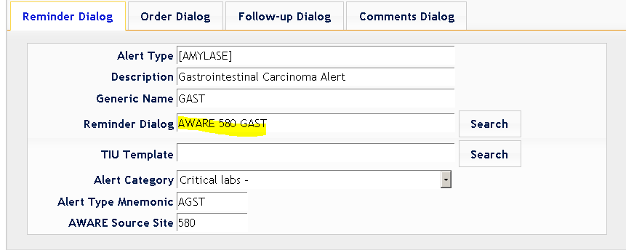

Figure - Add Newly-Created Reminder Dialog

1. Now from the DI Reminder Dialog Management option, change view to “E” (Dialog Elements) and define each dialog elements for the appropriate ORDER DIALOGS, FOLLOW-UP ACTIONS, or COMMENTS group one at a time from the design layout information starting at the top of the list prepared in Appendix A - Order Dialog/Orderable Item Site Customization/Tailoring. Use terminology for defining the Reminder Dialog elements using AWARE with originating station number + mnemonic + unique description. Example: AW580 GAST Bone CT Scan.

Select Item: Next Screen// **CV Change View**

Select one of the following:

D Reminder Dialogs

**E Dialog Elements**

F Forced Values

G Dialog Groups

P Additional Prompts

R Reminders

RG Result Group (Mental Health)

RE Result Element (Mental Health)

TYPE OF VIEW: R// **E Dialog Elements**

**Dialog List** Mar 28, 2014@15:00:32 Page: 2 of 84

DIALOG VIEW (DIALOG ELEMENTS)

+Item Dialog Name Dialog type Status

17 AW500 CXRY OTHER FOLLOW-UP COMMENTS Dialog Element

18 AW500 CXRY OTHER FOLLOWUP COMMENTS Dialog Element

19 AW500 CXRY PAT NO LONGER IN CARE Dialog Element

20 AW500 CXRY PAT OPTED NO TREAT Dialog Element

21 AW500 CXRY REFER TO ANOTHER VA PROV Dialog Element

22 AW500 CXRY REPEAT CXR Dialog Element

23 AW500 CXRY REPEAT CXR OTHER Dialog Element

+ + Next Screen - Prev Screen ?? More Actions >>>

AD Add CV Change View INQ Inquiry/Print

CO Copy Dialog PT List/Print All QU Quit

Select Item: Next Screen// **ADD**

**NOTE:** Do not fill in the details at this time, just define a proper name for each element.

You MUST use a name appropriate for the association with a leading AW+OriginatingStationName and Mnemonic and description. Example : AW580 GAST CT Bone Scan.

Select DIALOG to add: **AW580 GAST CT BONE SCAN**

Are you adding 'AW580 CT GAST BONE SCAN' as a new REMINDER DIALOG (the 2090TH)? No// **Y (Yes)**

Not used by any other dialog

NAME: AW580 GAST CT BONE SCAN//

DISABLE:

CLASS: **L LOCAL**

SPONSOR: **^**

Input your edit comments.

Edit? NO//

Repeat the process for all dialog elements as prepared in step 1 above.

1. Now in the KB Editor “Add” equivalent Alert Type dialog elements in sequential order for each Reminder Dialog Group (starting with the Reminder Order Dialog Group, the Follow-up Group, and then Comments Group) to the corresponding group in the KB Editor using the ADD button from each KB Editor Alert Type Group. Define the KB editor Alert type elements with a Dialog Box Text field value described for each element in the design layout in Appendix A - Order Dialog/Orderable Item Site Customization/Tailoring.

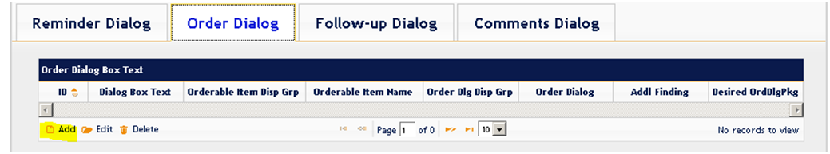

Figure - Add Alert Type Dialog Elements

Use Search button to select a value for “Desired Reminder Element” from among a search list of associated Reminder dialog elements, each associated Reminder dialog element in its Reminder Group for each KB Editor Alert type Dialog Box Text in the equivalent KB Editor Alert Type Dialog Group. To search, use appropriate naming terminology for this Alert type (AW + mnemonic, i.e. AW580 GAST). Then make a selection among available choices, and click the “Update and Close” to save. Repeat the process until all dialog elements are appropriately defined/added to their corresponding KB Editor dialog groups.

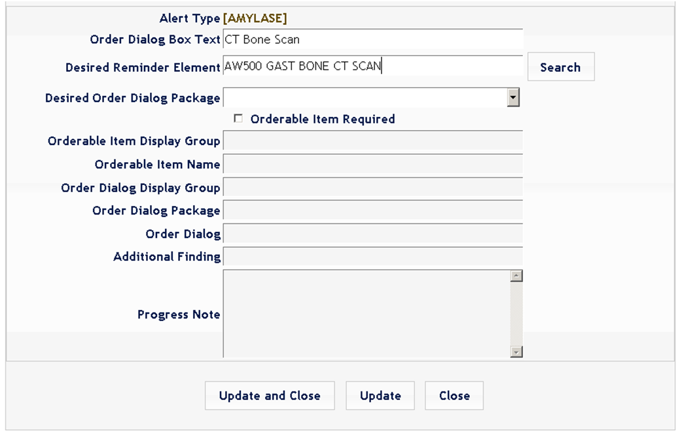

Figure - Search Alert Type

1. Make health factors for each of those dialog elements. Use terminology using AWARE with originating station number + mnemonic + unique description. Example: AW580 GAST Bone CT Scan.

Select OPTION NAME: **PCE TABLE MAINTENANCE** PXTT TABLE MAINTENANCE PCE Table Maintenance

INFO PCE Information Only ...

ACT Activate/Inactivate Table Items ...

CED Education Topic Copy

DEWO PCE Delete Encounters W/O Visit

ED Education Topic Add/Edit

EX Examinations Add/Edit

**HF Health Factors Add/Edit**

IM Immunizations Add/Edit

SK Skin Tests Add/Edit

TR Treatments Add/Edit

Select PCE Table Maintenance Option: **HF Health Factors Add/Edit**

Select HEALTH FACTORS: **AW580 GAST BONE CT SCAN**

Are you adding 'AW500 GAST BONE CT SCAN' as

a new HEALTH FACTORS? No// **Y (Yes)**

HEALTH FACTORS ENTRY TYPE: **FACTOR FACTOR**

FACTOR: AW500 GAST BONE CT SCAN Replace

INACTIVE FLAG:

ENTRY TYPE: FACTOR//

CATEGORY: **REMINDER FACTORS**

SHORT NAME:

USE ONLY WITH SEX:

DISPLAY ON HEALTH SUMMARY: **Y YES**

1. Next, return to Reminder Dialog menu and change view to “E” (Dialog Elements) then add the associated health factors to appropriate dialog element in the ADDITIONAL FINDING field.

At the same time, enter Progress Note text desired for Progress Note recording of follow-up action into the DIALOG/PROGRESS NOTE TEXT field. Repeat the process for all dialog elements in all 3 Reminder Dialog Groups.

Select Item: Next Screen// **CV Change View**

Select one of the following:

D Reminder Dialogs

**E Dialog Elements**

F Forced Values

G Dialog Groups

P Additional Prompts

R Reminders

RG Result Group (Mental Health)

RE Result Element (Mental Health)

TYPE OF VIEW: R// **E Dialog Elements**

**Dialog List** Mar 28, 2014@16:19:18 Page: 5 of 84

DIALOG VIEW (DIALOG ELEMENTS)

+Item Dialog Name Dialog type Status

68 AW580 GAST ADMINISTOR STATIN Dialog Element

69 AW580 GAST CARCINOID SYNDROME Dialog Element

70 AW580 GAST COMMENTS Dialog Element

**71 AW580 GAST CT BONE SCAN Dialog Element**

72 AW580 GAST FOLLOW-UP SCHEDULED Dialog Element

73 AW580 GAST REFER TO PROVIDER Dialog Element

74 AW580 GAST SURGICAL EXCISION Dialog Element

+ + Next Screen - Prev Screen ?? More Actions >>>

AD Add CV Change View INQ Inquiry/Print

CO Copy Dialog PT List/Print All QU Quit

Select Item: Next Screen// **71**

Dialog Name: AW580 GAST CT BONE SCAN

Current dialog element/group name: AW580 GAST CT BONE SCAN

Used by: AWARE 580 GAST ORDER DIALOGS GROUP (Dialog Group)

NAME: AW580 GAST CT BONE SCAN Replace

DISABLE:

CLASS: LOCAL//

SPONSOR:

REVIEW DATE:

RESOLUTION TYPE:

ORDERABLE ITEM:

FINDING ITEM:

Select ADDITIONAL FINDING: **AW580 GAST BONE CT SCAN**

Searching for <others>

Searching for a HEALTH FACTORS

AW500 GAST BONE CT SCAN

...OK? Yes//

Additional findings:

HF AW580 GAST Bone CT Scan Finding # 1

DIALOG/PROGRESS NOTE TEXT:

1>**Bone Scan Taken.**

For Comments Dialog Element, add additional prompt by selecting SEQUENCE in the dialog element.

EXCLUDE FROM PROGRESS NOTE:

SUPPRESS CHECKBOX:

Select SEQUENCE: **1**

ADDITIONAL PROMPT/FORCED VALUE: **PXRM COMMENT** prompt NATIONAL

...OK? Yes// (Yes)

OVERRIDE PROMPT CAPTION: **Comments:**

START NEW LINE: **Y YES**

EXCLUDE FROM PN TEXT:

REQUIRED:

Select SEQUENCE:

1. Return to the KB Editor, select the Alert Type and open one of the dialog elements. Click “Update” button to update the Additional Finding and Progress Note for all dialog elements one at a time starting within the Order Dialog, then Follow-up Dialog, and then Comment Dialog Group.



AW580 GAST Bone CT Scan

Bone Scan Taken

Figure – Update Additional Finding and Progress Note

1. For each Dialog element in the KB Editor’s Orders’ tab , specify the following fields:
   1. Desired Order Dialog Package (make selection among choices available from pull-down list)
   2. Orderable Item required (No/Yes). “Check the “Check Box” if it is required.
2. Do site specific customization (design) for all Order Dialog elements and any associated Orderable item, and then use as applicable in a Reminder Dialog’s Order’s Group's dialog elements.

Use the following set of instructions:

* 1. Make Quick orders with or w/o orderable items for medications, labs, consults, procedures, and imaging tests, etc. to be used with the designed Reminder Dialog Group’s Reminder dialog elements. Use of consults also involves connecting to and/or setting up site-specific consult services.

First define and configure these quick orders (including defining any consults and their consult services, etc), for your site. Define with your own site equivalent lab test names, consult/consult services, medications and procedures.

* 1. Then edit the quick order name into each Reminder Dialog element’s “Finding Type” field, and if applicable, any associated orderable item name into the Reminder Dialog’s “Orderable Item” field. If no Orderable item applies, remove or enter no Orderable item in this field. Do this for all Reminder Dialog elements in the Orders Reminder Dialog Group.
  2. Then click the “Update” function a Validation check for each of the corresponding KB Editor Order tab’s Order dialog element for these Reminder Dialog elements starting with the first element under the Order’s tab. This will then reflect the aforementioned updates in the Reminder Dialog Group’s Reminder Dialog elements into the corresponding Order tab’s Order dialog elements. These “updates” are shown for the “Output” (O) fields of the KB Editor’s Order tab's Order dialog elements.

The following fields should be updated upon a successful validation:

* + 1. Orderable Item Display Group
    2. Orderable Item Name
    3. Order Dialog Display Group
    4. Order Dialog Package
    5. Order Dialog

1. Define the Alert Type’s TIU Template and connect it to the Reminder Dialog

The TIU template chosen needs to be linked with the associated Reminder Dialog through parameterization via the PARAMETER DEFINITION NAME: TIU TEMPLATE REMINDER DIALOGS (See the Vista_Install_Setup_Validation_InitialTesting.doc) .

1. Now test the Reminder Dialog manually in CPRS to test its elements are working properly.
2. Finally, activate the Alert Type from the Reminder Dialog page of the Alert Type by checking the “Active” checkbox at the bottom panel. An Initiation Date will be filled in upon first time when activation is successful. This new Alert Type is now ready to be used.

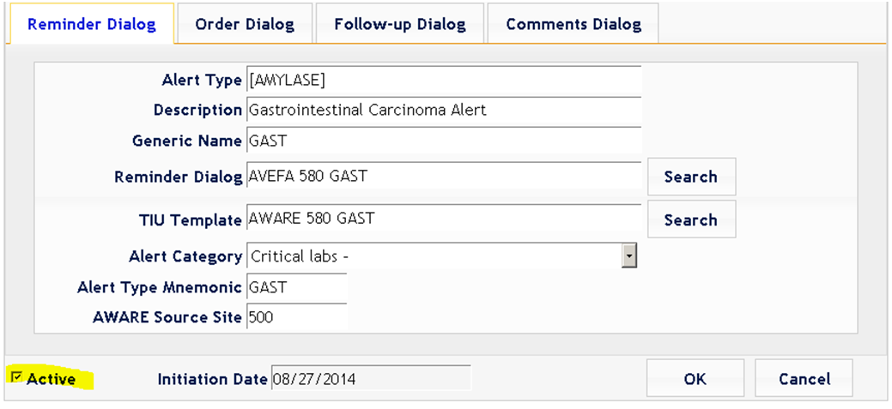

Figure - Activate the Alert Type